Prelab

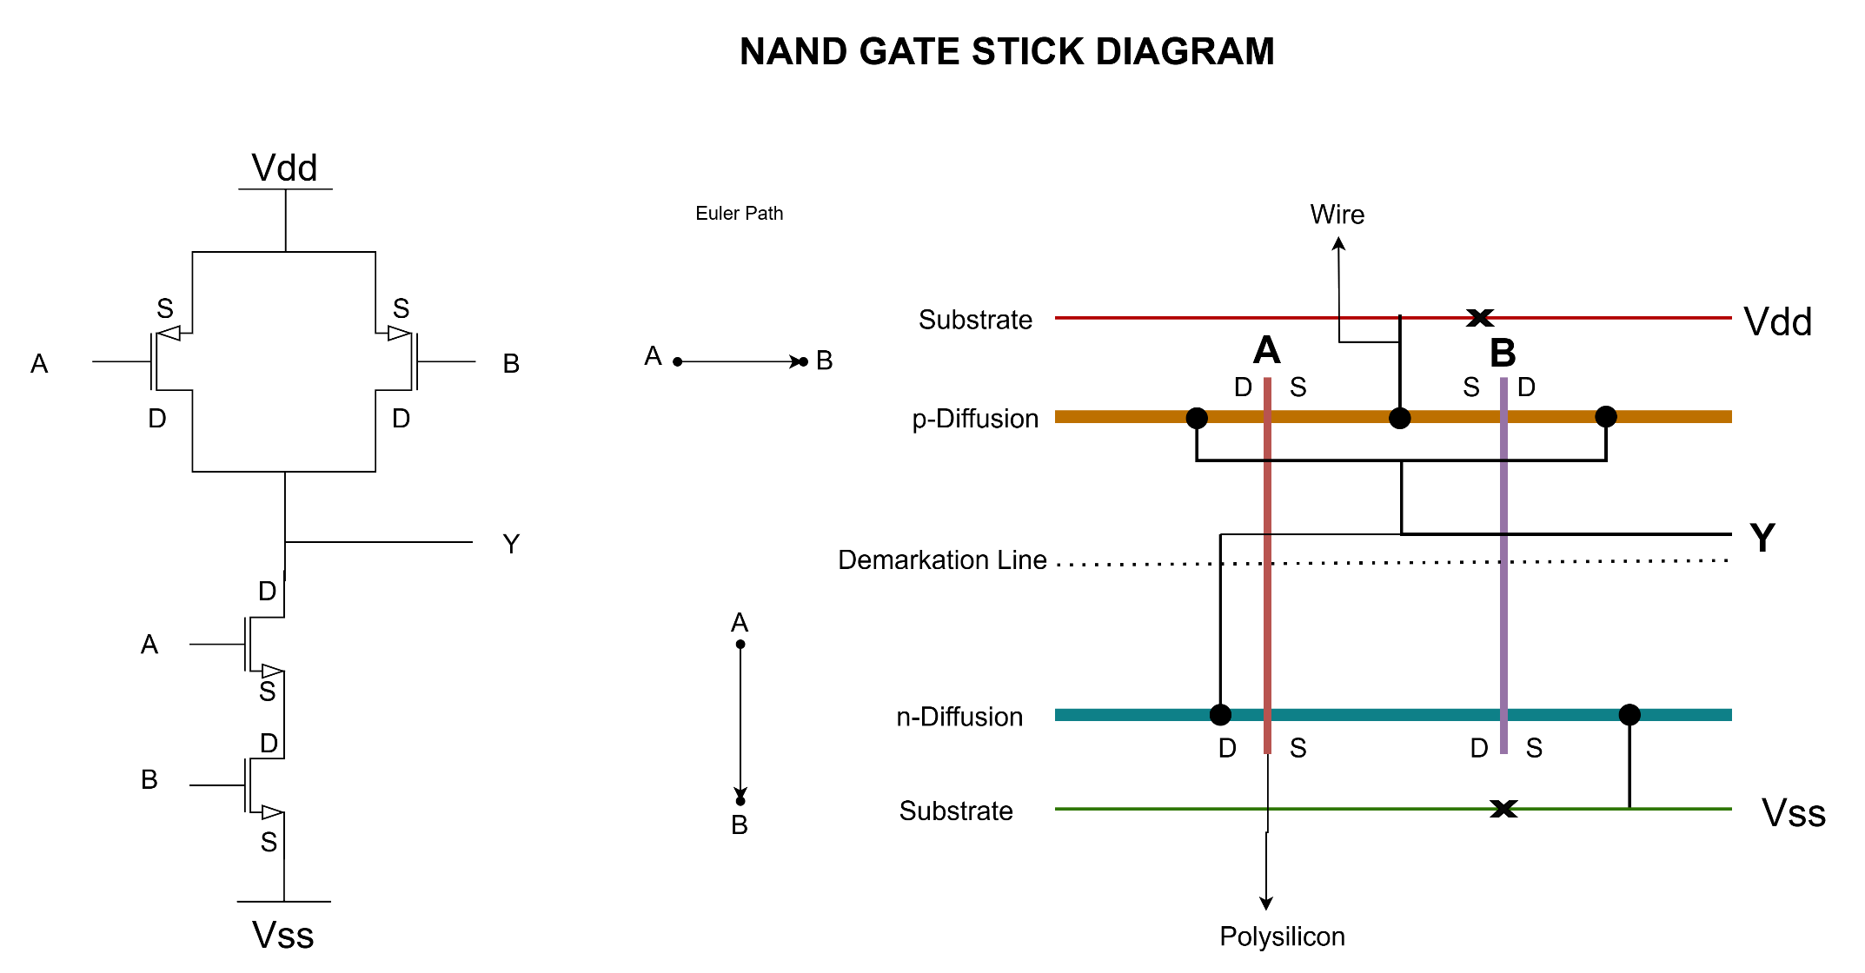

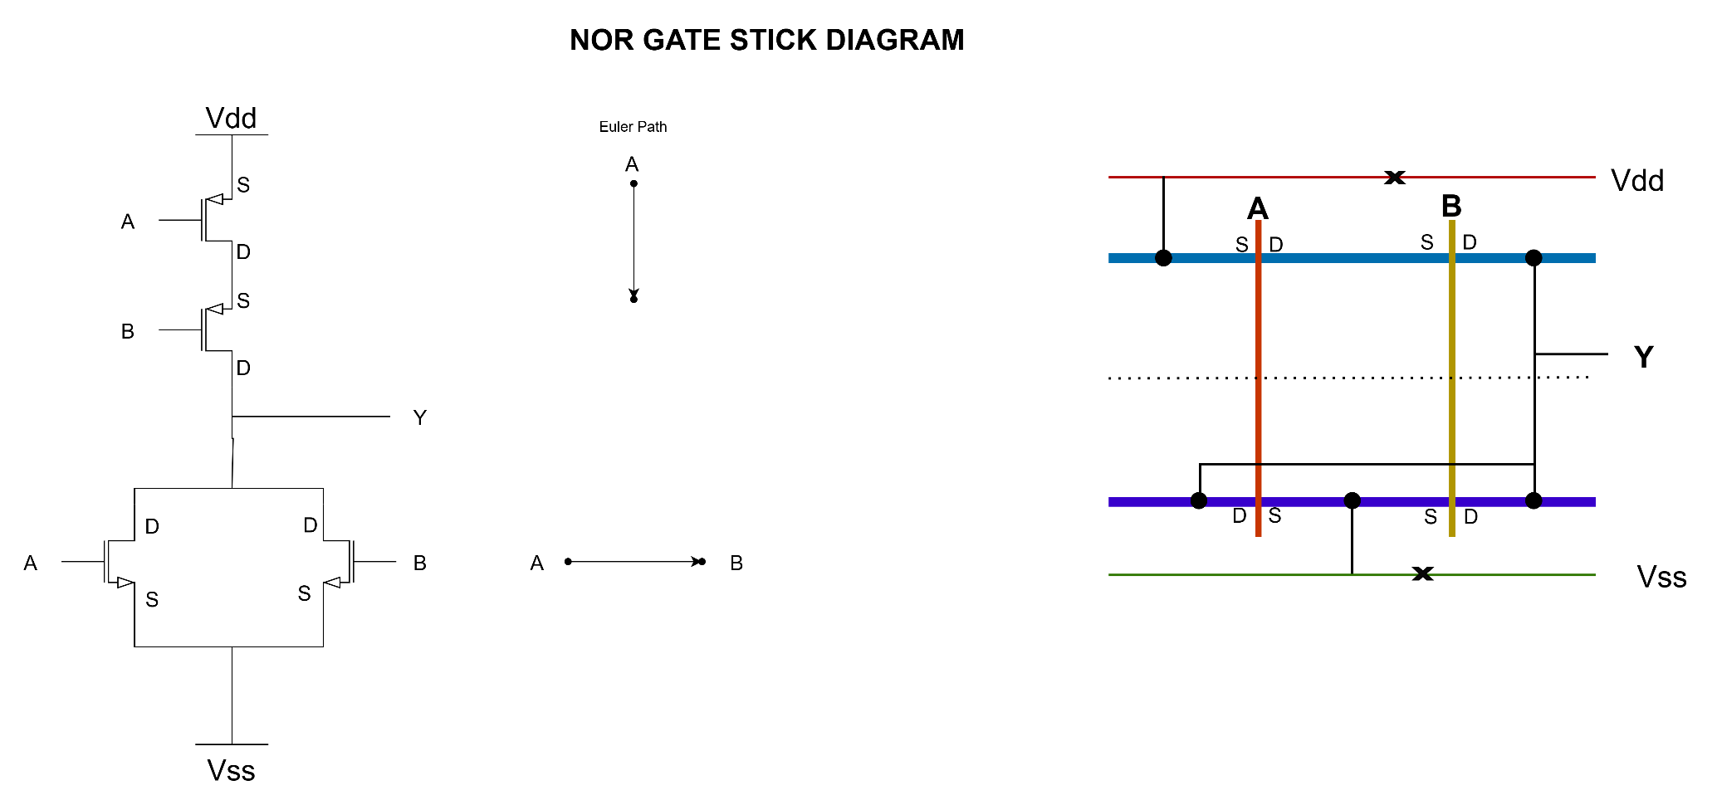

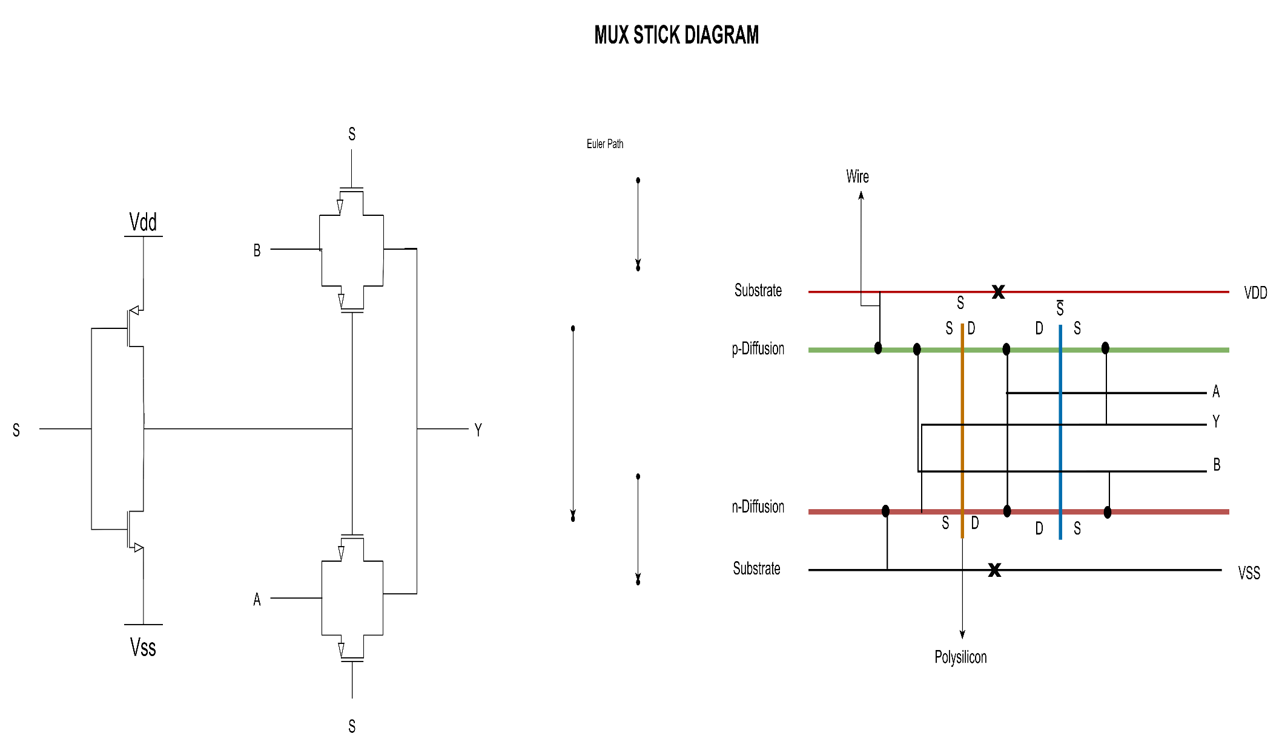

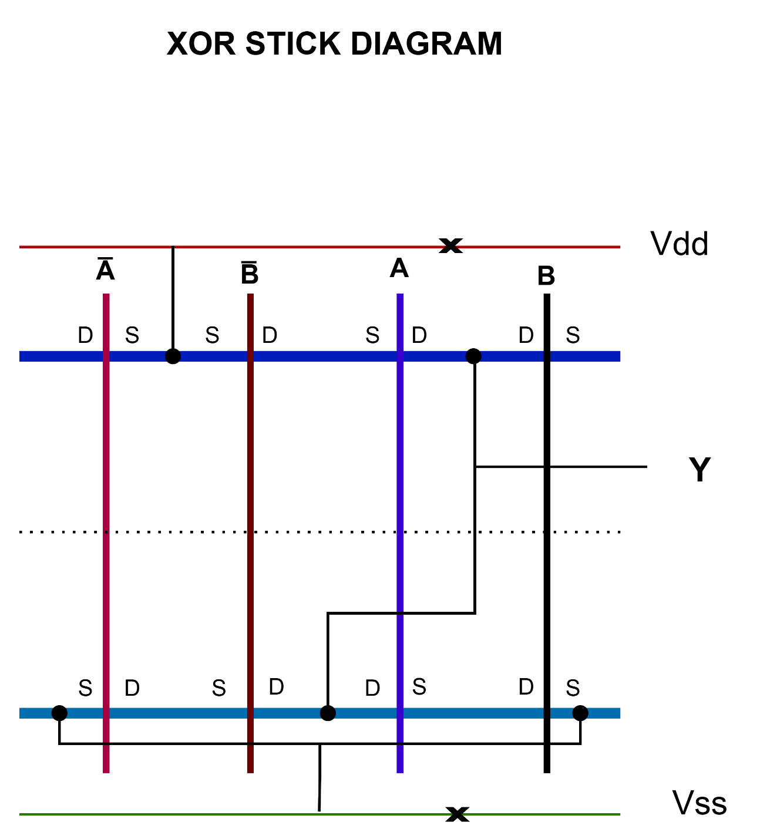
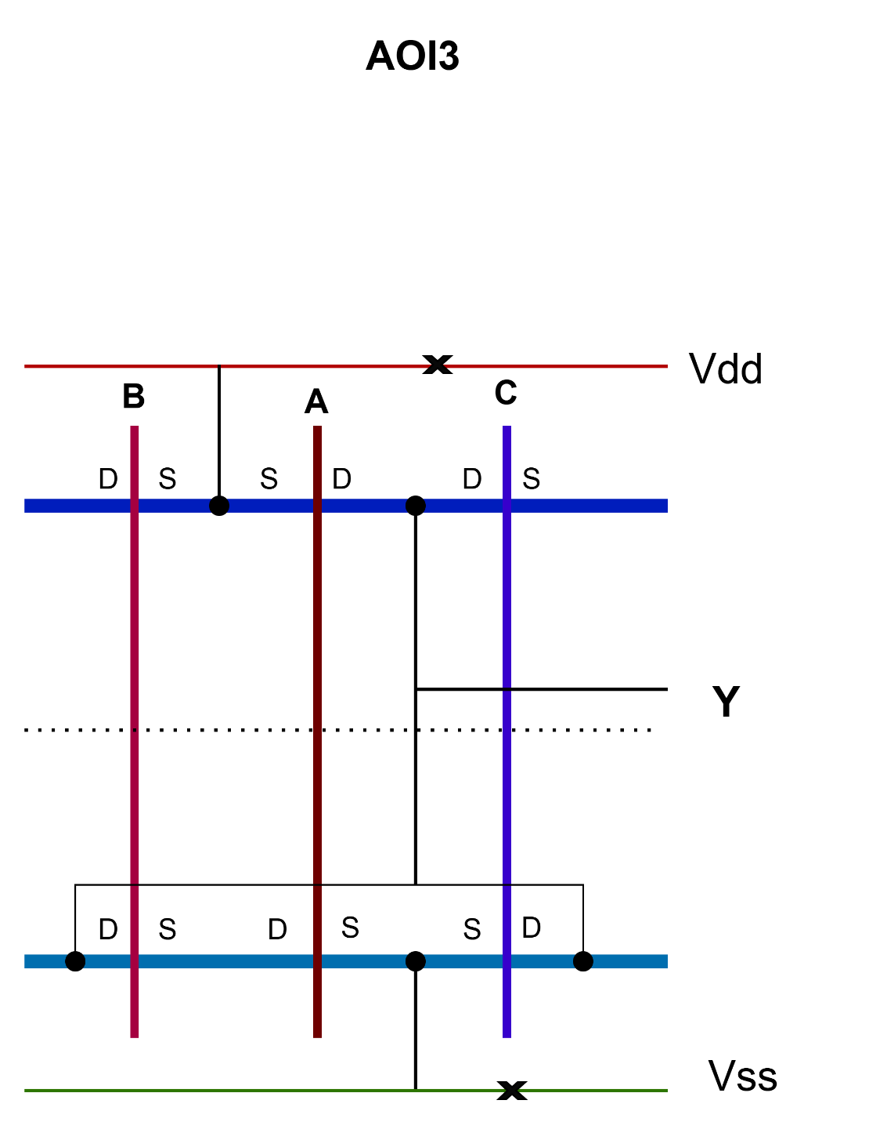
Inverter Dimension
P oxide:
Length: 0.325
Width : 0.24

N oxide:
Side length: 0.12
Center length: 0.145
Total length: 0.385

Center width: 0.12
Total width: 0.24
Grove width before and after center block = total width – center width /2 = 0.06

